Math 1 Name_______________________________

**6-2 Parallel Lines Introduction** Date________

In the figure below, .

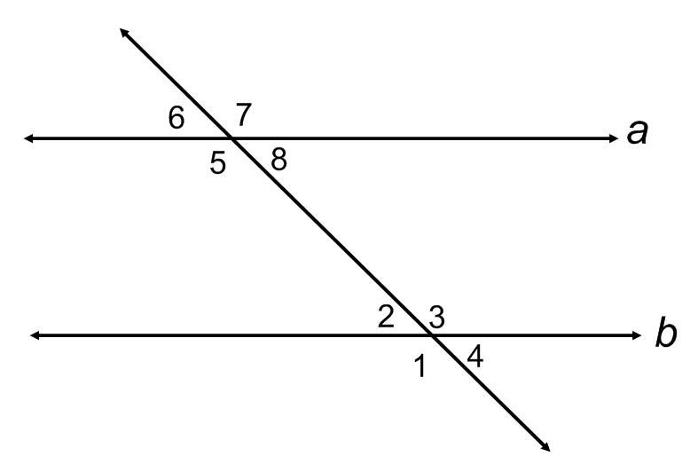

|  |  |  |  |  |  |  |  |
| --- | --- | --- | --- | --- | --- | --- | --- |
|  | **Linear Pair** | **Vertical Angles** | **Corresponding Angles** | **Alternate Interior** | **Alternate Exterior** | **Same-Side Interior** | **Same-Side Exterior** |
| **Examples** |  |  |  |  |  |  |  |
| **Angle Relationship** |  |  |  |  |  |  |  |